**American Ancestors®, the country’s oldest nonprofit genealogical organization, names its research library for entrepreneur and philanthropist Brady Brim-DeForest**

**Boston, MA, April 23, 2025**—American Ancestors®, a national nonprofit center for family history, heritage, and culture, has named its historic library after one of its most generous patrons, entrepreneur, philanthropist, and author Brady Brim-DeForest. The Brim-DeForest Library is an independently funded research library open to the public with one of the largest collections of family heritage materials in the world, recently described by *USA Today* as “one of the 10 great places to trace family roots...” and by *AARP Magazine* as a premier destination for family history research.

The Brim-DeForest Library occupies multiple floors of the recently renovated American Ancestors headquarters at 97 Newbury Street in Boston’s Back Bay. It is home to a world-class collection of books, maps, manuscripts, photographs, and digital resources dedicated to genealogy and history. The collection’s holdings include some 200,000 print volumes, tens of thousands of microform records, and more than 28 million manuscription items, including rare handwritten and typed family histories and charts, material with vital statistic data such as town, church, and cemetery records, genealogical papers compiled by genealogical researchers and authors, family association collections, and original primary source documents donated by individuals and families. The collections, which continue to grow through acquisition and preservation activities, date from the fourteenth century to the present, and span North America, Europe, and beyond.

Brim-DeForest and his wife Jessica have contributed more than $1 million to American Ancestors to ensure that the nearly two-hundred-year-old library at American Ancestors remains a vibrant hub for the study of family history for generations to come.

“I believe that everyone should be able to explore their family tree, strengthen their connections to the past, and uncover the stories that shape their identities,” said Brim-DeForest. “My family and I are thrilled that the Brim-DeForest Library will provide future generations with the tools to discover and celebrate their unique heritage, while honoring our own ancestors through its new name.”

“For nearly two centuries, millions of people have used the resources at the Brim-DeForest Library to find out more about their ancestry,” said Ryan Woods, President and CEO of American Ancestors. “This generous gift from the Brim-DeForests ensures that our mission to serve the public and advance the study of family history will continue for many years to come.”

The multi-story American Ancestors complex that is home to the Brim-DeForest Library also houses the Family Heritage Experience, a new, interactive, state-of-the-art exhibition that introduces visitors to the joy of family history research.

The Brim-DeForest Library is open Tuesdays through Saturdays from 10 a.m. to 6 p.m. Access is free for American Ancestors members, and $25 for non-members.

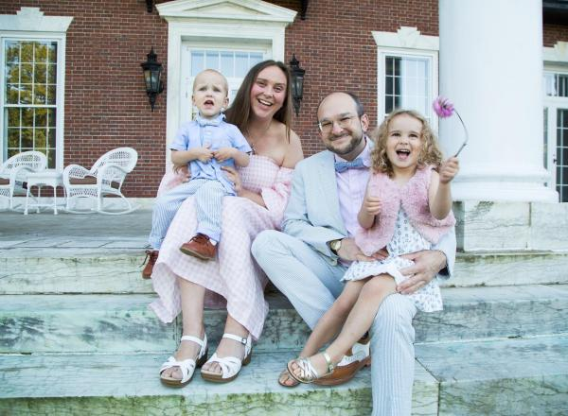 **About Brady Brim-DeForest**

Brady Brim-DeForest is the Managing Partner at Late Stage Capital, Chairman of BluShift Aerospace, and the former CEO of [Formula.Monks](https://www.formula.co/" \t "_blank" \o "https://www.formula.co/), a 7,500+ person global technology firm. His organizations have been on the Inc. 5000 list of fastest growing companies five times, and he is a regular contributor to Inc. and Forbes, and a member of the invite-only Forbes Technology Council. He is also a Life Fellow of the Royal Society of Arts, and the Royal Anthropological Institute of Great Britain and Ireland, and the Royal Geographical Society, among others. His latest book, *Smaller Is Better*, on the topic of the virtues of small technology teams, was recently covered by [GQ Magazine](https://www.gq.co.za/wealth/the-ceo-who-believes-smaller-is-better-brady-brim-deforest-is-challenging-the-traditions-of-the-consulting-world-2300154c-cdb6-4e3e-8e02-2e283b60c409).

**About American Ancestors**

American Ancestors® is a national nonprofit center for family history, heritage & culture based in Boston, Massachusetts that has been setting the gold standard for genealogical research since its founding in 1845. Today, American Ancestors serves 400K+ members and subscribers through AmericanAncestors.org, one of the world’s largest online collections of family history resources. In 2025, American Ancestors launched the Family Heritage Experience, an interactive, state-of-the-art exhibition that introduces visitors to the joy of family history research, located at 97 Newbury Street at our headquarters in Boston. American Ancestors is also home to the Wyner Family Jewish Heritage Center, which preserves New England’s Jewish history, and 10 Million Names, a project dedicated to finding the names of the enslaved men, women, and children in pre- and post-colonial America before emancipation. For more information, visit AmericanAncestors.org.

**Media Contact:** Claire Vail, claire.vail@americanancestors.org, 857.225.8738

###